**7. Removing blemishes and scars and smoothening skin:**

**Step 1:** Open an image in photoshop.

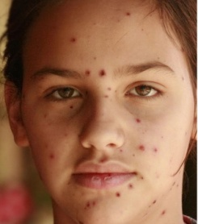

**Step 2:** Now by using heal brush directly swipe on the scar /blemish carefully .

**Step 3:** Repeat it for all the scars and blemishes .

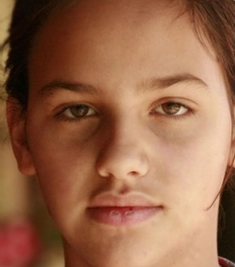

*🡨Final*